**VISHWAKARMA INSTITUTE OF INFORMATION TECHNOLOGY, PUNE**

**COMPUTER ENGINEERING DEPARTMENT**

**APRIL-MAY 2018**

**Synopsis**



**Group number: 11**

Group Members :

1. Chinmay Chitale.
2. Chinmay Patankar.
3. Prathamesh Ratolikar.
4. Sudershan Shivjatak.

Email-ID : chinmay.chitale@viit.ac.in

Mobile no : 9405391241.

**Title :** Clarify – A cross platform community based application to resolve real time queries**.**

**Objective :** To create a cross platform application for providing students a tailor suited solution for their questions in the format which they prefer.

**Abstract :** Our software, a cross platform application for student teacher community which will resolve query of the customers in a tailor suited way. The basic aim of this software is to benefit the student community by resolving their queries in a stipulated time. This software will also benefit the experts community who will be aboard with us as they can solve challenging questions everyday and will be rewarded accordingly. A full proof business strategy is designed to escalate business with the experts community with ease.

**Briefs about Contents:**

1. **Introduction :**

The aim of this application is to gather and analyze and give an in-depth insight of the complete student-teacher based interactive learning  system by defining the problem statement in detail. Nevertheless, it also concentrates on the capabilities required by stakeholders and their needs while defining high-level product features. The detailed requirements of the student-teacher based interactive learning system are provided in this document.

1. **Technical Details :**

This project will be using the following technology stack.

1. Performance Constraint
   1. Supports 10 Concurrent database connections.
   2. Storage space limit is of 250 Gb.
   3. Verification Emails can be sent 40000 per month.
   4. Only one server instance.
   5. Currently database speed is 10 DTU which can be extended upto 3000 DTU.
2. Hardware Specification
   * 1. Android api level 5.0 or higher.
     2. Ios 8 or higher.
     3. Windows 10 (build 1503) or higher.
3. Memory specification.
   * 1. Requires 1 Gb ram to run properly.
4. **Working :**

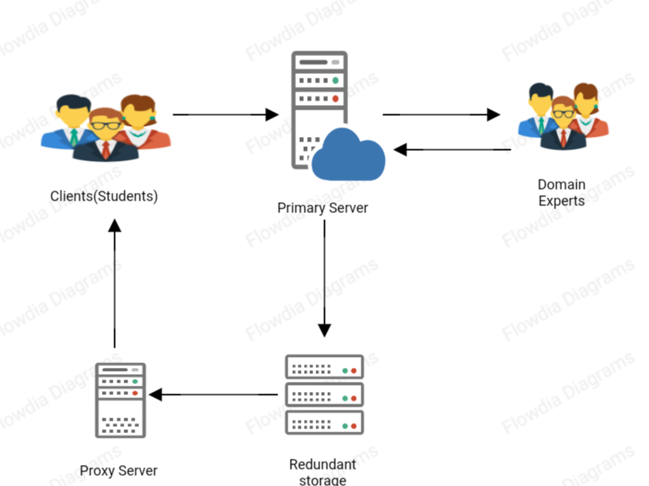

Above is the proposed working model of our application. Our application will be accepting question from the clients storing them on the server, ten searching the right domain experts for the questions and forwarding the questions to them.

Then the domain experts will submit the answers to the question back on the server and the server will store these answers on the redundant storage. Then the proxy server will forward to answers to the clients.

1. **Applications:**
2. Online Platform for students to get their doubts solved.
3. Online platform for students to earn and learn by becoming a domain expert.

**References/Bibliography:**

<https://docs.microsoft.com/en-us/xamarin/>

<https://docs.microsoft.com/en-us/azure/>

<https://docs.microsoft.com/en-us/visualstudio/?view=vs-2017>

<https://en.m.wikipedia.org/wiki/Agile_software_development>

<https://www.projectinsight.net/project-management-basics/basic-project-management-phases>

<https://blogs.msdn.microsoft.com/microsoft_press/2016/09/01/free-ebook-microsoft-azure-essentials-fundamentals-of-azure-second-edition/>

<https://sendgrid.com/docs/index.html>

<https://www.codeproject.com/Articles/4416/Beginners-guide-to-accessing-SQL-Server-through-C>

<https://m.youtube.com/watch?v=1EpYqtSlOr8>

<https://www.c-sharpcorner.com/ebooks/azure-web-apps-for-developers>

<https://www.c-sharpcorner.com/ebooks/xamarin-forms-for-beginners>

<https://www.c-sharpcorner.com/ebooks/beginning-c-sharp-object-oriented-programming>